**Carroll College Winterfest Cardboard Sled Race**

***“It’s all downhill from here”***

**Saturday February 1st 2025 On Guad Hill. Races Begin: 1:00 p.m.**

Design and build a sled out of corrugated cardboard. It must be capable of withstanding the descent down Guad Hill and to a finish line. (Need at least 10 teams to make this a viable event)

**Awards include:** 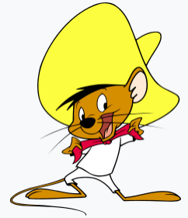   

Speedy Gonzales Award for fastest time. Prize **$200**

Vogue Award for most spectacular looking sled. Prize **$100**

Mona Lisa Award for most attractive/artful looking sled. Prize **$100**

Ricky Gervais Award for the most spirited/fun team. “looks don’t matter here” Prize **$100**

**RULES:**

Safety and fun are our objectives. Competition is secondary. For safety, you have to follow these rules. For fun, you need to follow them with a smile on your face and remember that this is an event organized and run by volunteers who work very hard to ensure everyone has a safe and fun experience.

**CONSTRUCTION:**

• Inspection: All sleds must pass an inspection before they will be allowed on the hill.

• Sleds must be free of sharp edges, pointy objects or any other feature that may be deemed dangerous by inspectors. If you are unable to remove such objects, your sled will not be allowed to race.

• ONLY corrugated cardboard may be used, held together with tape and glue.

• Sleds must NOT be wrapped in plastic, tape, shrink wrap, or anything else.

• Only seams and joints may be taped, not the entire sled.

• A sled’s underside can be waxed – but 50% of that portion which touches the snow must be left exposed – no tape, paint, shrink wrap or other material.

**ABSOLUTELY NO USE OF THE FOLLOWING:**

* Corrugated plastics or corrugated materials
* Non-corrugated cardboard such as carpet tubes
* Cardboard that is bonded to other materials
* Epoxy glue or Epoxy-reinforced cardboard
* Glues that harden into solids
* Tar-based substances
* Fiberglass resin
* Two-part varnished or any other two-part substances
* Screws, nails or staples of any type or material
* Mechanical fasteners

**RULESE AND REGULATIONS**

Student Activities may amend these rules and regulations as needed.

* **Mandatory for all sled racers to wear helmets. (bicycle helmet, ski helmet, etc.)**
* Two racers must be in or on the sled and no more than six racers to a sled.
* To have a qualifying time, all riders must have stayed on the sled from the start to the finish.
* The format will be a timed event. Fastest time wins the **coveted** Speedy Gonzales Award
* If a sled does not pass inspection or re-inspection by staff, it will not be allowed the participate or may not be allowed on the hill. (you will have the opportunity to adjust your sled)
* Please arrive 30 minutes before your race time to check-in.
* Racers are allowed to receive a push-off at the top of the hill.
* Sled construction shall consist of cardboard, glue and tape.
* Come up with a team name to use for the day.
* **Your team and all riders must have read and understand the rules.**
* **All participants must fill out an Acknowledge of Risk Form.**

**GRUDGE MATCHES:**

If you wish to race against another sled team, this will be accomplished following the conclusion of all scheduled races. Talk with officials at the Registration Desk.

**FINALLY, REMEMBER -- THIS IS ALL FOR FUN!! THINK SAFETY FIRST!!**

**Please get your Entry Form in by Jan 22nd Drop off at rm 131 Borromeo - so we know we have enough teams for the event.**

**Carroll College 1st Annual Cardboard Sled Race**

***“It’s all downhill from here!”*** **Entry Form**

**Saturday February 1st 2025 On Guad Hill. Races Begin: 1:00 p.m.**

Design and build a sled out of corrugated cardboard. It must be capable of withstanding the descent down Guad Hill and to a finish line. (Need at least 10 teams to make this a viable event) Note: If we need more snow we will postpone until the snow allows us to put on the event. Sleds can be stored in the Noonan Center. **Entry form due Jan 22nd**

Name of your Sled (Team Name): ______________________________________

**You must have at least 2 people and no more than 6 people riding on the sled.**

Names of the People Riding the Sled with their ID #s

1. ______________________________________________________
2. ______________________________________________________
3. ______________________________________________________
4. ______________________________________________________
5. ______________________________________________________
6. ______________________________________________________

* All riding the sled must fill out an Acknowledgement of Risk Form – Please turn in these forms with this Entry Form.

Names and ID#s of others on the team who may not be riding the sled:

1. ______________________________________________________
2. ______________________________________________________
3. ______________________________________________________
4. ______________________________________________________

* Those not riding do not have to fill out an Acknowledgement of Risk Form.

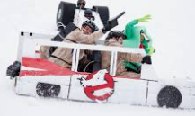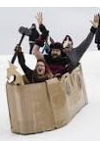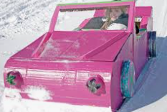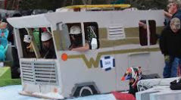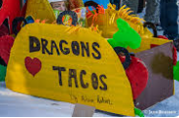

**Carroll College Winterfest**

**Cardboard Sled Race**

***“It’s all downhill from here”***

**Saturday February 1st 2025**

**On Guad Hill.**

**Races Begin: 1:00 p.m.**

**$500 in Prizes!!**

**Why?: To Celebrate Life and Friendships at Carroll College!!**

**And for the Fun of it.**

**Participate or come watch!**